1. Design the below webpage using angular as “myapp”. Create a module named mod. Create a controller named calc. The controller is registered to the module. calc has a function named Count. When OK button is clicked make a call to the function and display how many times the button is clicked.

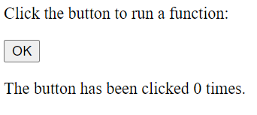

<!DOCTYPE html>

<html>

<script src="https://ajax.googleapis.com/ajax/libs/angularjs/1.6.9/angular.min.js"></script>

<body ng-app="myApp">

<div ng-controller="calc">

<p>Click the button to run a function:</p>

<button ng-click="Count()">OK</button>

<p>The button has been clicked {{cnt}} times.</p>

</div>

<script>

let mod = angular.module('myApp', []);

mod.controller('calc', function($scope) {

$scope.cnt = 0;

$scope.Count = function() {

$scope.cnt++;

};

});

</script>

</body>

</html>

1. Design the following webpage using angular with a module as “myapp”. On clicking calculate display the total and interest amount in the appropriate filed. Use a controller named interest and define the method calculate() in it.

1. Design the below webpage using angular as “myapp”. Create a module name mymodule. Create controller named calculator. Define two methods such as add and multiply in the controller. Call the respective method on clicking the button Add and Multiply and display the result in the Result input tag.

